Investigation 14A: ATMOSPHERIC Optical Phenomena

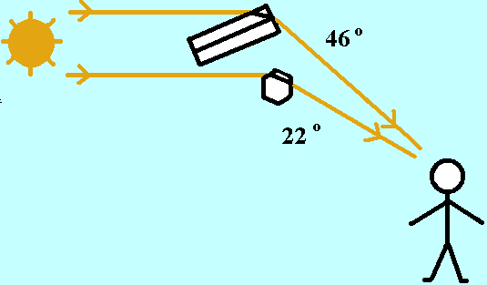

1. "As shown in Figure 2, the observer would need to look in the general direction ________ the Sun to see a halo. (Caution: never look directly at the Sun! Sky observations near the Sun need eye protection or blockage of the Sun’s direct rays, such as with your hand.)"
- toward
- away from

2. "Halos indicate clouds that are composed of ________."
- ice crystals
- liquid droplets

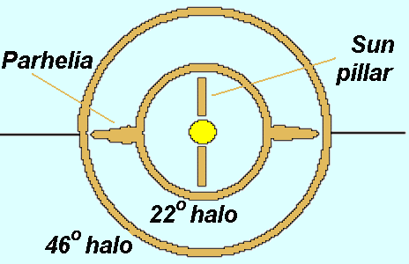

3. "Parhelia, commonly called sundogs or mock suns, are bright spots sometimes seen at and just outside the 22° halo circle at the same level as the Sun. The term “sundogs” refer to the dogs that followed the mythological chariot of Mercury, the sun god. Parhelia are primarily formed by the refraction of light passing through hexagonal plate crystals oriented with their relatively large top and bottom six-sided surfaces generally horizontal (falling much like single playing cards which remain horizontal after released from a horizontal position). Parhelia have some coloration caused by refraction of light through the crystals. The distance of parhelia from the Sun increases with increasing solar altitude; at solar altitudes greater than about 60 degrees, parhelia cannot be observed. Stable atmospheric conditions and the jpresence of horizontal ice crystal surfaces favor the appearance of parhelia and sun pillar, but only _____ require the passing of light through crystals.
- parhelia
- sun pillars

4. "Figure 4 suggests the orientation that raindrops would have to the Sun’s rays and the observer’s location for the formation of a rainbow. The color separation in the primary and secondary rainbows is formed from refraction of the ray both on entering and on leaving a drop. The longer wavelength red light is refracted slightly less than the shorter wavelength violet, resulting in the color separation. The primary rainbow has a single internal reflection of the ray whereas the secondary bow results from ________ reflections of the ray inside the drop."
- one
- two
- three

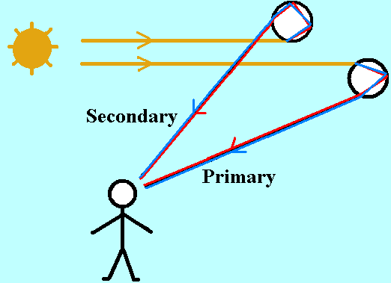

5. "Rainbows would be seen by looking generally ________ the Sun."
- toward
- away from

6. "Observing a rainbow can provide weather forecasting hints. A rainbow seen in the morning would be produced by rain falling generally to the ________ of the observer."
- east
- west

7. "Because weather systems generally move from west to east, this bow-producing rainshower would move ________ the observer. So, fair weather might be delayed."
- toward
- away from

8. "In a similar way, a rainbow seen in the afternoon is a harbinger of ________ weather to follow."
- stormy
- clearing

9. "Because raindrops have curved surfaces, one ________ expect to see sun pillars or other surface reflection phenomena from raindrops."
- would
- would not

10. "Rays from drops produce rainbows in circular arcs about the antisolar point, the point opposite the Sun along a line from the Sun through the observer’s eyes. The angle measured where straight lines from the antisolar point and from a point on the primary rainbow meet in the observer’s eye is about 42°. It is about 50° for the secondary bow. Someone claiming to have seen a rainbow ringing the Sun ________."
- could be right
- would actually have seen a halo

11. "Many raindrops must be involved in order for an observer to see a rainbow. A raindrop must be oriented at an angular width of slightly more than 42° to deliver red to the observer’s eye while another drop must at slightly less than 41° to deliver violet to the same eye at the same instant. Consequently, red is the ________ color in the arc of a primary rainbow. Millions of raindrops fill in the colors of the rainbow to form the bow that can form a circular arc that sometimes stretches from horizon to horizon under proper rain and sunlight conditions."
- outer
- inner

Applications

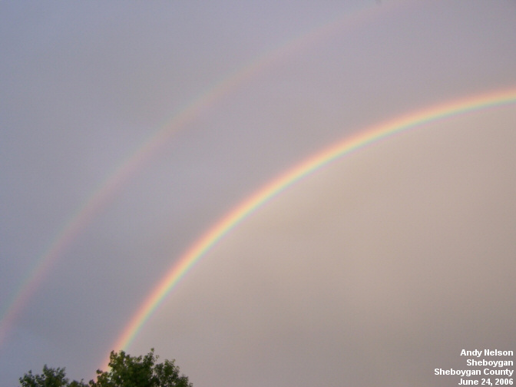

12. "A view of a primary and a secondary rainbow is shown in Figure 5. The anti-solar point, the point opposite the Sun along the line from the Sun through the observer’s eyes, is to the lower right corner off the photo. The rainbow forms on a circular arc about that point. With the Sun in the sky and assuming the observer is on a smooth Earth surface with a sea horizon, the anti-solar point is below the horizon so that less than half of the circle on which a rainbow could be formed would be above the horizon. Here the arc of the more colorful primary rainbow separates the part of the image with the lightest background from the part with the darker background. From the inside of the primary rainbow outwards, the colors range from ________."
- red to violet
- violet to red

13. "The primary rainbow is formed from the Sun’s rays being refracted upon entering a drop, being reflected within the drop, and then refracted again upon leaving the drop. A secondary rainbow would be formed with an additional reflection inside the drop. A faint portion of the secondary rainbow can be seen in the image, well “outside” of the primary bow. The color sequence in the secondary rainbow is reversed from the primary bow, with reddish hues appearing on the ________ of the secondary rainbow arc."
- inside
- outside

14. "As described earlier in this investigation, light rays may also be reflected and refracted by ice crystals in the atmosphere. Ice crystals interact with light to form halos, as seen in Figure 6. The ring centering on the Sun is a 22-degree halo. The halo is formed by light being refracted through the ice crystals to the observer while the observer looks in the general direction ________ the light source."
- away from
- toward

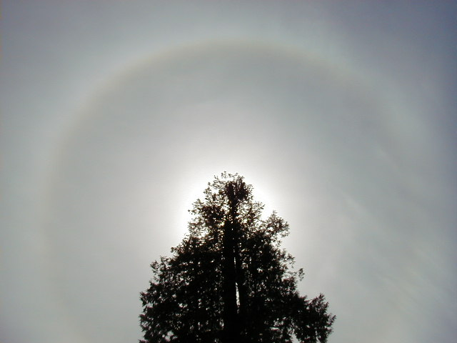

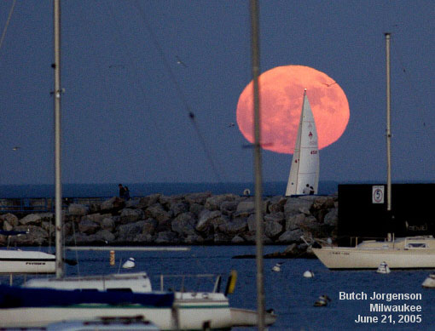

15. "The image shows the Moon just above the horizon distorted from a circular disc. This departure from a circle results from the Moon’s rays traveling through air of varying densities near the Earth’s surface. Light from the lower edge of the Moon’s disk passes through air of greater density (hence lower speed) than light from the upper edge of the Moon’s disk. Consequently, the lower beam undergoes ________ refraction, causing the Moon’s lower limb to be elevated more than the upper limb. As the Moon rises higher into the sky and light from across its surface experiences little atmospheric refraction, the Moon’s disk appears more and more circular."
- less
- more

